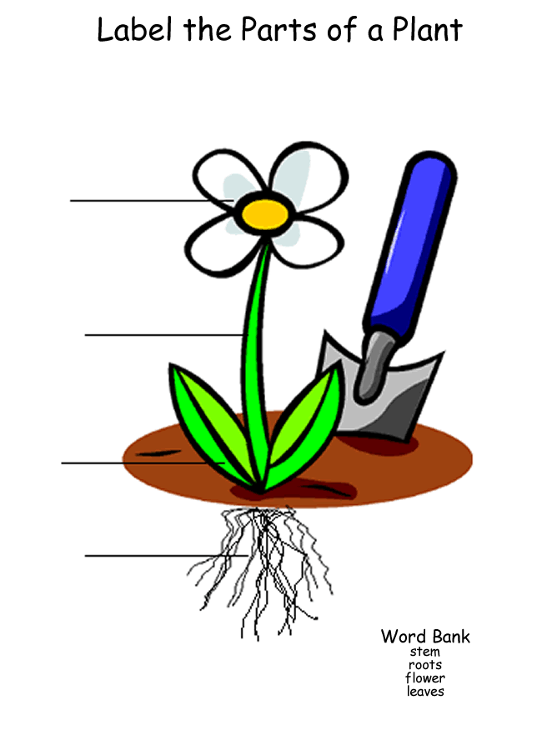

Use a word from the box
Flower, root stem leaves living things flowers fruits

- Roots absorb ______________________ from the ___________________.
- Leaves use __________________ to produce ______________________.
- Flowers help to ____________________.
- Stem helps to __________________ the ____________________ .
- The main parts of the plants are: ____________________, _____________________,___________________,___________________.
- Plants are part of ____________________________.
- Plants produce ___________________ and _______________________.

